**Description**

As a user I should be able to view activities if found that matches search criteria I entered.

------------------------------------------------------------------------------------------------------------------------------------------

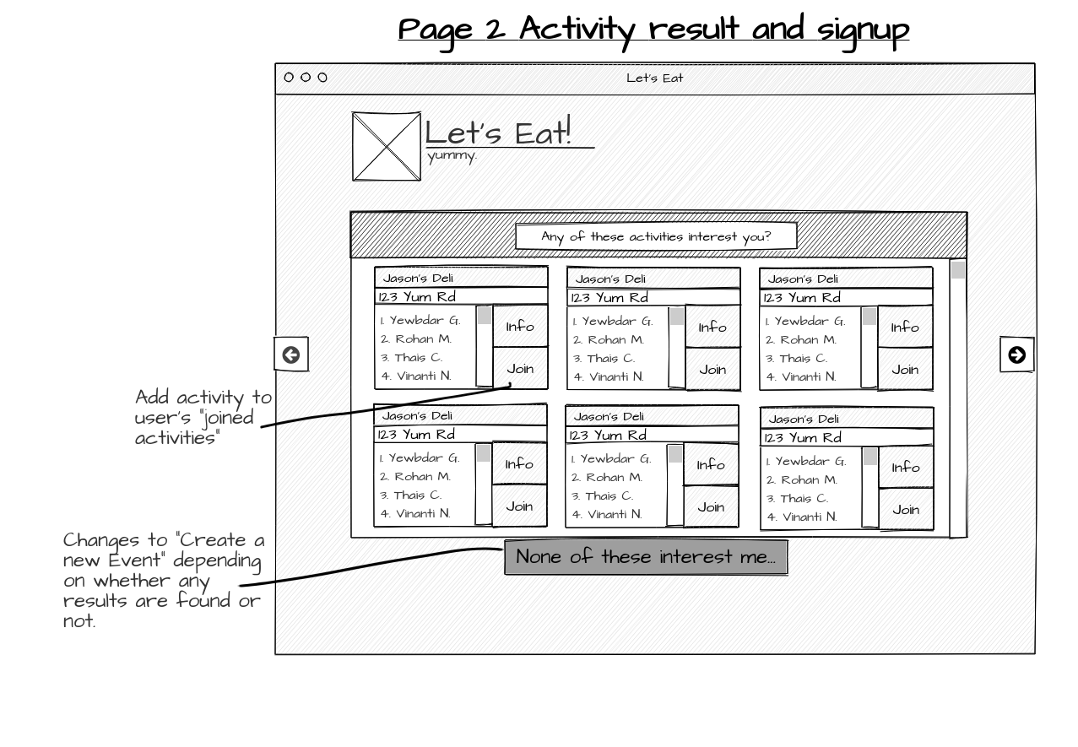

**Acceptance criteria**

* If there are activities ,Page should also display option to click “None of these interest me”
* Each activity is displayed with all the ~~group member’s names~~ the number of people who have already joined the activity, **and how many seats are left available** in the activity
* Each activity has an option to “join”.
* When “Join” button is clicked it should navigate the user to User information page.
* If there are no activities then, button should say “Create new activity”.
* Both options “None of these interest me “ and “create new activity” when clicked should navigate the user to the new activity list page.